DIS-POINTS- SAVANNAH RIVER- Bainbridge, Georgia

# 3 3/8" Blue Cream SAVANNAH RIVER

SHAPE \* MERGEFORMAT 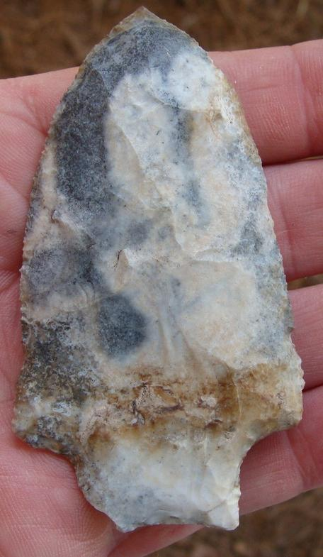 SHAPE \* MERGEFORMAT 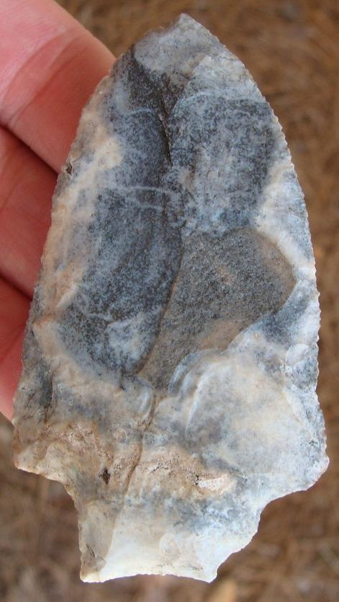

Sold by [riverrelics](http://myworld.ebay.com/riverrelics) ( [13425](http://feedback.ebay.com/ws/eBayISAPI.dll?ViewFeedback&userid=riverrelics) )

### Delivery package 1 of 1

Delivered on Thursday, Sep 24, 2015

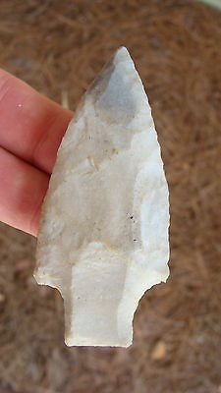

#### [Stunning 3 1/8" FLUTED LEVY Deep South Arrowhead Artifact ~30~](http://www.ebay.com/itm/371419912691)

|  |  |
| --- | --- |
| Item price | $27.99 |
| Quantity | 1 |
| Item number | 371419912691 |
| Shipping service | USPS First Class Package |

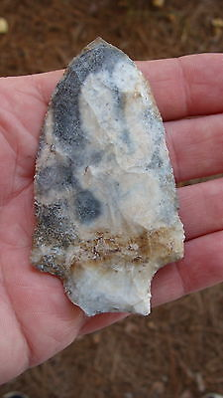

#### [Killer 3 3/8" Blue Cream SAVANNAH RIVER Deep South Arrowhead Artifact ~30~](http://www.ebay.com/itm/391234521189)

|  |  |
| --- | --- |
| Item price | $31.00 |
| Quantity | 1 |
| Item number | 391234521189 |
| Shipping service | USPS First Class Package |

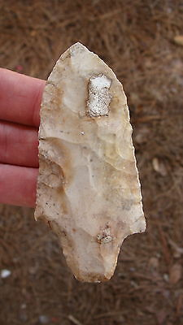

#### [Huge 3 3/4" ALACHUA Deep South Arrowhead Artifact ~30~](http://www.ebay.com/itm/391234544537)

|  |  |
| --- | --- |
| Item price | $36.75 |
| Quantity | 1 |
| Item number | 391234544537 |
| Shipping service | USPS First Class Package |